### **MapReduce and PageRank**

**Question 1**:

Suppose our input data to a map-reduce operation consists of integer values (the keys are not important). The map function takes an integer *i* and produces the list of pairs (*p*,*i*) such that *p* is a prime divisor of *i*. For example, map(12) = [(2,12),(3,12)].

The reduce function is addition. That is, reduce(*p*,[*i*1,*i*2,...,*ik*]) is (*p*,*i*1+*i*2+...+*ik*).

Compute the output, if the input is the set of integers 15, 21, 24, 30, 49.

Sol:

**prime no:2,3,5,7,11,..........  
15:[3,15],[5,15]  
21:[3,21],[7,21]  
24:[2,24],[3,24]  
30:[2,30],[3,30],[5,30]  
49:[7,49]  
by combining all common elements part i.e compare left element and add rightmost element of that to get the solution.  
[2,(24+30)],[3,(15+21+24+30)],[5,(15+30)],[7,(21+49)]**

**Question 2**:

Consider three Web pages with the following links:

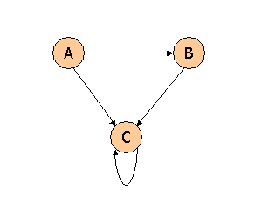

Suppose we compute PageRank with a β of 0.7, and we introduce the additional constraint that the sum of the PageRanks of the three pages must be 3, to handle the problem that otherwise any multiple of a solution will also be a solution. Compute the PageRanks *a*, *b*, and *c* of the three pages A, B, and C, respectively.

**Solution:**

**import numpy as np**

**Adjacency matrix**

**m1 = [ 0, 0, 0]**

**[0.5, 0, 0]**

**[0.5, 1, 1]**

**m1 = np.matrix([[0, 0, 0],[0.5, 0, 0],[0.5, 1, 1]])**

**beta = 0.7**

**r = beta * m1 * r + ((1-beta)/N)**

**def r_p(r):**

**return beta * m1 * r + np.matrix([0.1,0.1,0.1]).T**

**r = np.matrix([1.0/3,1.0/3,1.0/3]).T**

**for i in range(1000):**

**r = r_p(r)**

**print "Final PageRank: \n" + str(r*3)**

**Final PageRank:**

**[[ 0.3 ]**

**[ 0.405]**

**[ 2.295]]**

**Question 3**:

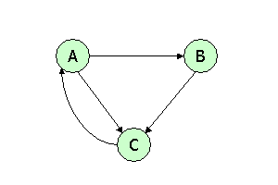

Suppose we compute PageRank with β=0.85. Write the equations for the PageRanks *a*, *b*, and *c* of the three pages A, B, and C, respectively.

**Solution:**

**import numpy as np**

**# Adjacency matrix**

**# m2 = [ 0, 0, 1]**

**# [0.5, 0, 0]**

**# [0.5, 1, 0]**

**m2 = np.matrix([[0, 0, 1],[0.5, 0, 0],[0.5, 1, 0]])**

**beta =0.85**

**def r_p(r):**

**return beta * m2 * r + np.matrix([0.05,0.05,0.05]).T**

**r = np.matrix([1.0/3,1.0/3,1.0/3]).T**

**for i in range(1000):**

**r = r_p(r)**

**print "Final PageRank: \n" + str(r)**

**Final PageRank:**

**[[ 0.38778971]**

**[ 0.21481063]**

**[ 0.39739966]]**

**Question 4**:



Assuming no "taxation," compute the PageRanks *a*, *b*, and *c* of the three pages A, B, and C, using iteration, starting with the "0th" iteration where all three pages have rank *a = b = c* = 1. Compute as far as the 5th iteration, and also determine what the PageRanks are in the limit.

**Solution:**

**import numpy as np**

**# Adjacency matrix**

**# m3 = [ 0, 0, 1]**

**# [0.5, 0, 0]**

**# [0.5, 1, 0]**

**m3 = np.matrix([[0, 0, 1],[0.5, 0, 0],[0.5, 1, 0]])**

**beta = 1**

**r = np.matrix([1,1,1]).T**

**for i in range(50):**

**r = m3.dot(r)**

**print i+1**

**print "Final PageRank: \n" + str(r)**

**Final PageRank:**

**[[ 1.20000002]**

**[ 0.59999999]**

**[ 1.19999999]]**